THE PRESENTATION TITLE (Bold; Times New Roman 14)

J. White¹, M. Black^{2,*} (bold; Times New Roman 12)

¹First Affiliation, City, Post Code, Country (italic; Times New Roman 12)
²Second Affiliation, City, Post Code, Country

* corresponding author: author@server.edu (Times New Roman 11)

Keywords: keyword 1, keyword 2, keyword 3, keyword 4 (Times New Roman 11)

(Times New Roman 12) The abstract should be written in English on an A4 paper size using the Times New Roman font, size 12 points, and single line spacing. The abstract cannot exceed one page in length. It should be formatted according to the template provided. The Abstract must be submitted using the ABSTRACT SUBMISSION bookmark on our web page (https://este2025.uwr.edu.pl )
The names of the authors, written in bold, should be with initials of first names only, followed by the last names in full. Commas should separate the names of the authors. Underline the name of the presenting author and put an asterisk (*) after the name of the corresponding author. Numbers should appear after the author's surname and then before each affiliation. Figures can be inserted into the abstract text only as JPG files of good quality. Figure captions must be italicized and should be put below the figures. References should be consecutively numbered in the text using square brackets and listed by the numbers at the very bottom of the page as regular text (not inserted automatically, as offered by MS Word). Acknowledgments must be italicized.
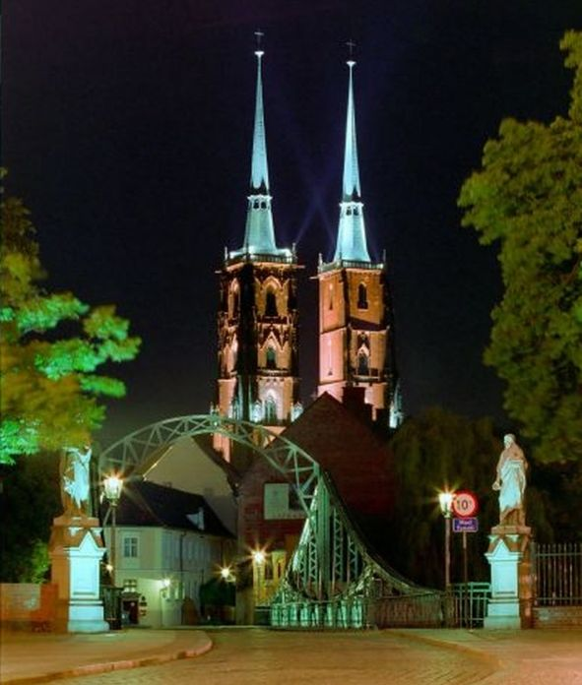
Leave one blank line after the title, list of authors, list of affiliations, abstract text (before References), and references (before Acknowledgements). Leave two blank lines between keywords and abstract text. Do not type "Abstract" at the beginning of the main text. Do not type “References” before their list and “Acknowledgements” before the acknowledgments.
Do not insert indentation at the beginning of paragraphs. There should be one blank line above and below an equation.
Abstracts will appear in the Abstracts Book as submitted without any editing. This is the sole responsibility of the Authors to prepare their abstracts according to this template.
Fig. 1. The night view of Tumski Bridge and the Cathedral towers in the oldest part of Wroclaw.
Name the abstract file using the first and second name of the corresponding author: John_White1.pdf (John_White2.pdf if one corresponding person supplies two abstracts).

[1] J. Kowalski, J. Lumin. 150 (2008) 143.

Acknowledgments: Write acknowledgments here, at the very end.

